**Nabeel Hussain**

**CMSC 203**

**Fall 2015**

**Assignment #4**

This assignment is to implement a GUI application which will keep a database of movies that contains information about them and their current week sale. It will keep a record of previous week’s sale as well.

**Test Case Screenshots:**

**currWeekSale.txt**

**prevWeekSale.txt**

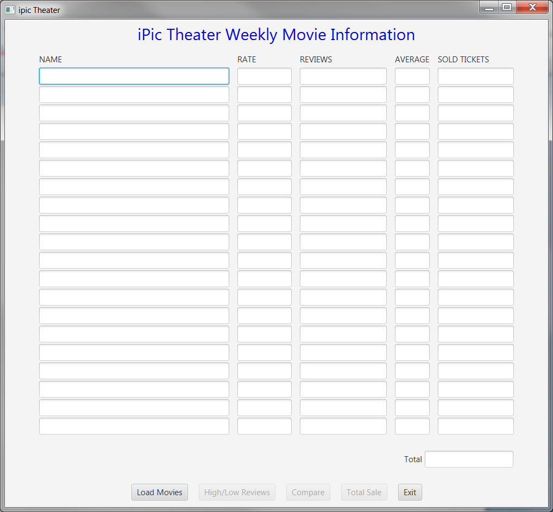

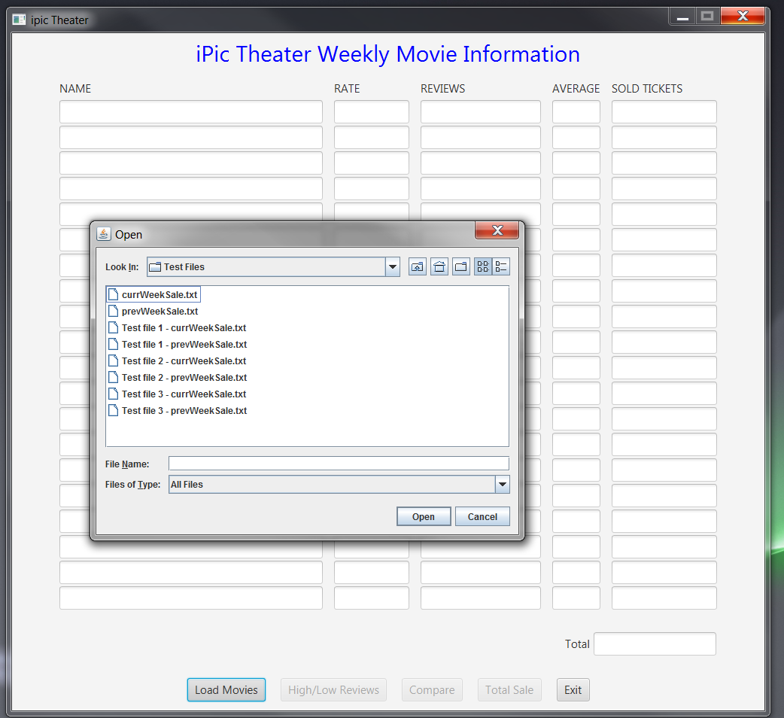

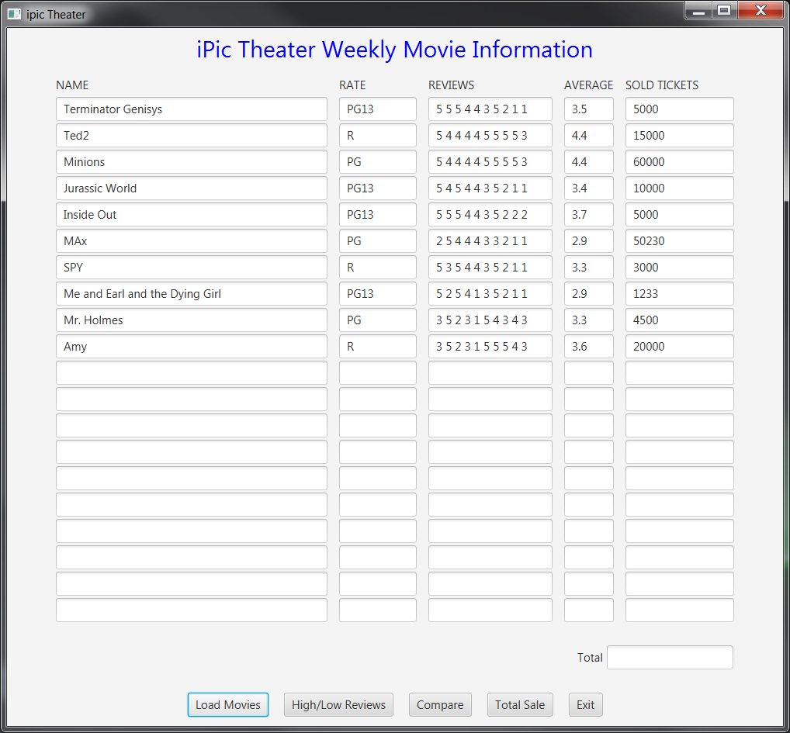

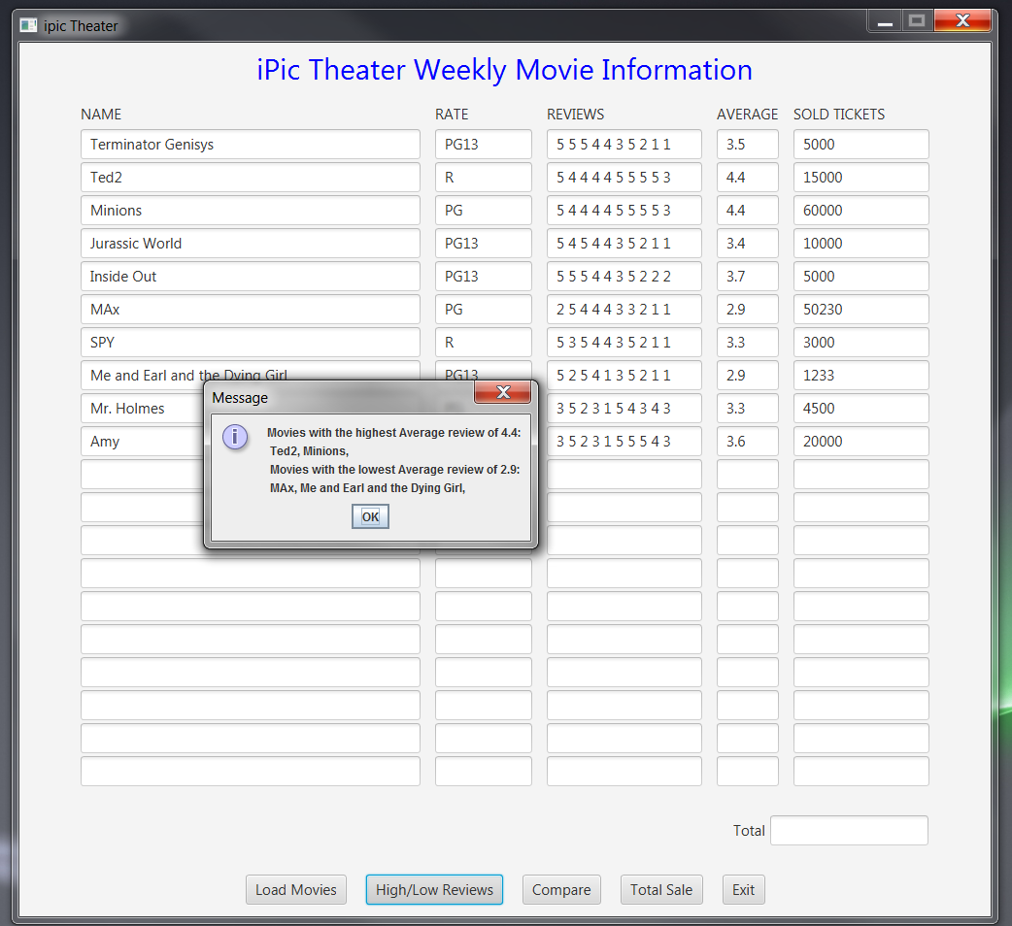

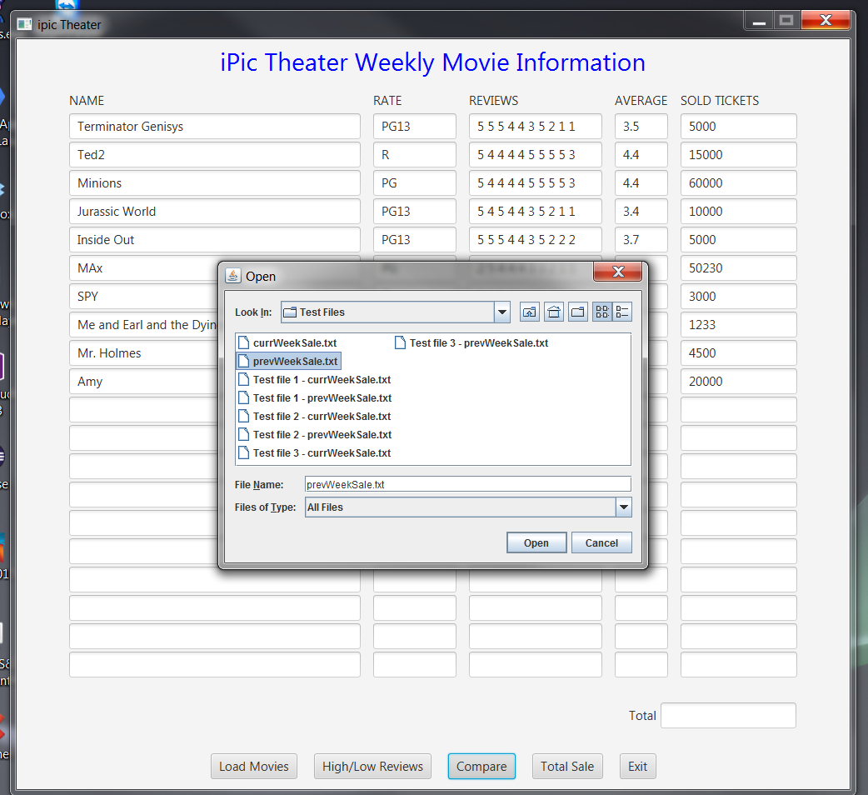

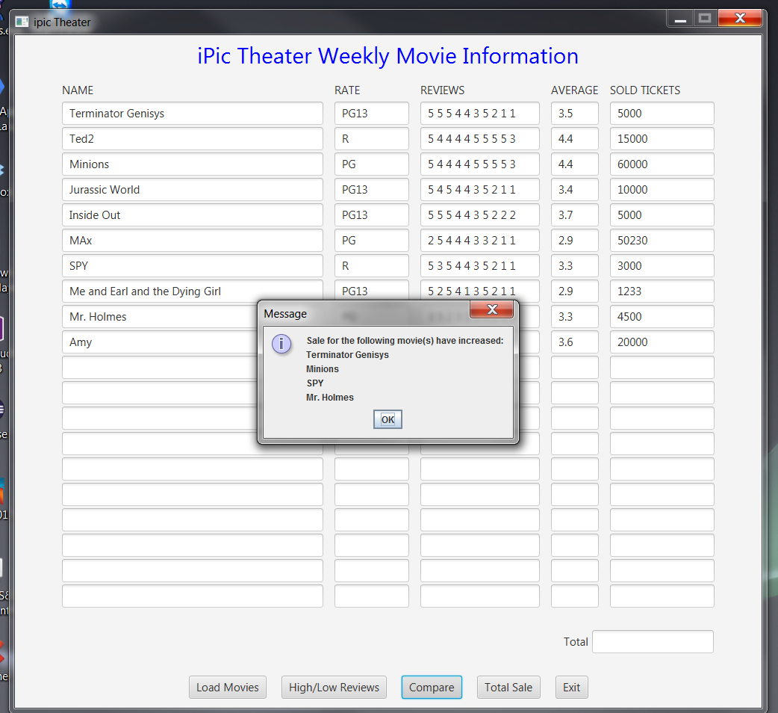

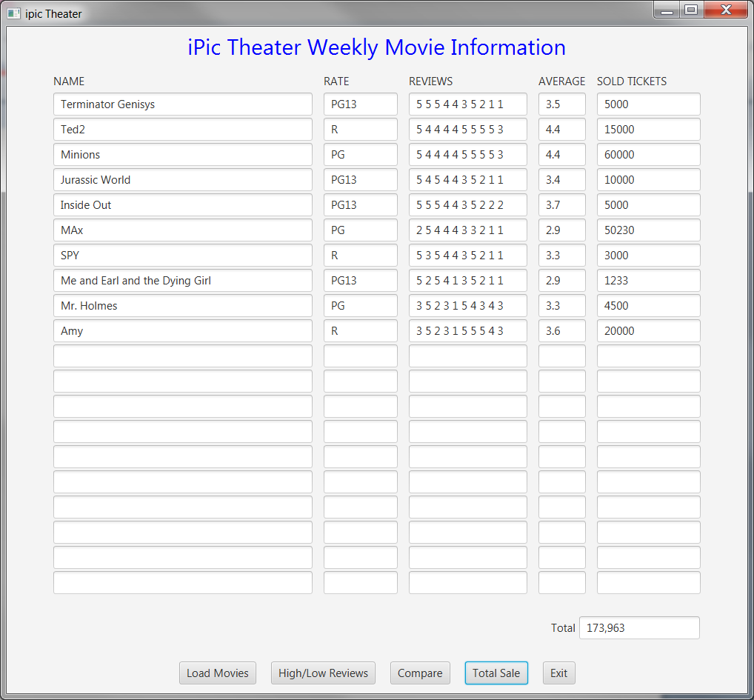

**Test file 1 - currWeekSale.txt**

**Test file 1 – prevWeekSale.txt**

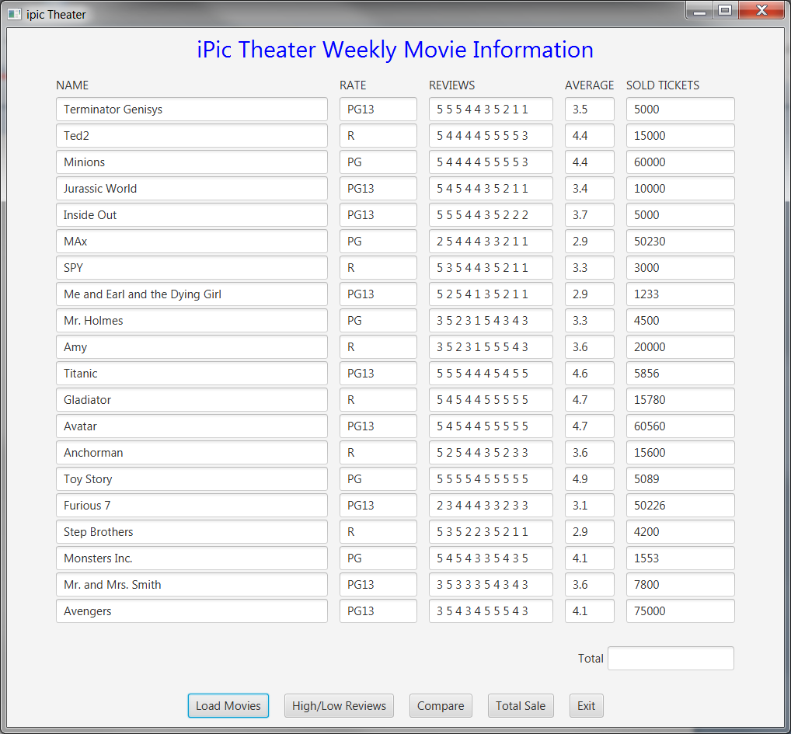

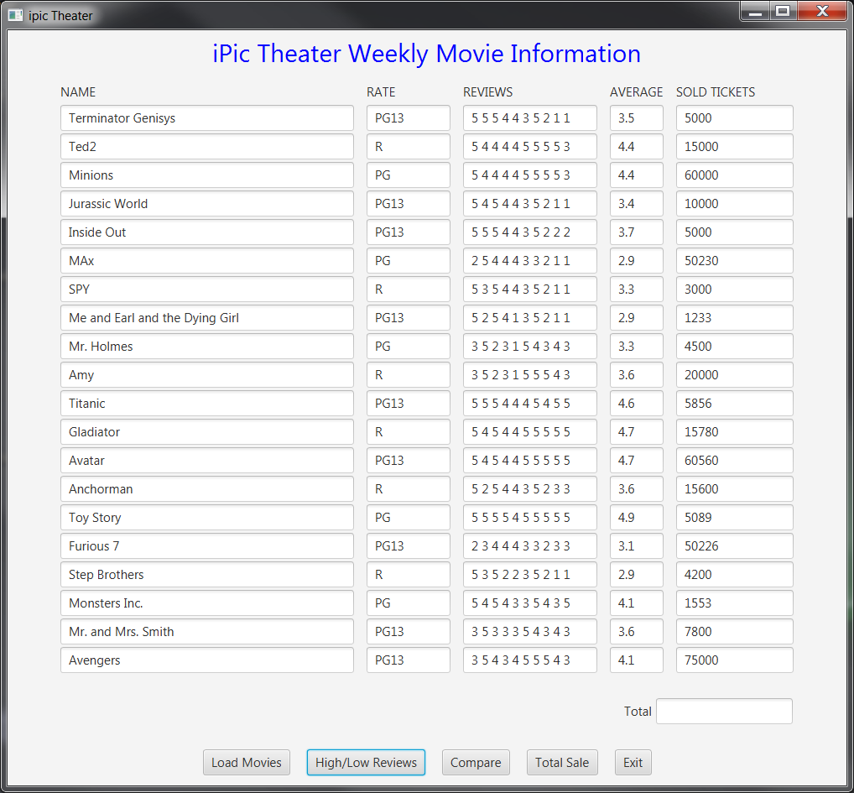

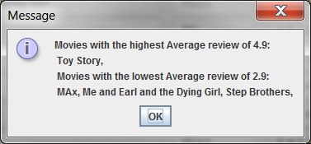

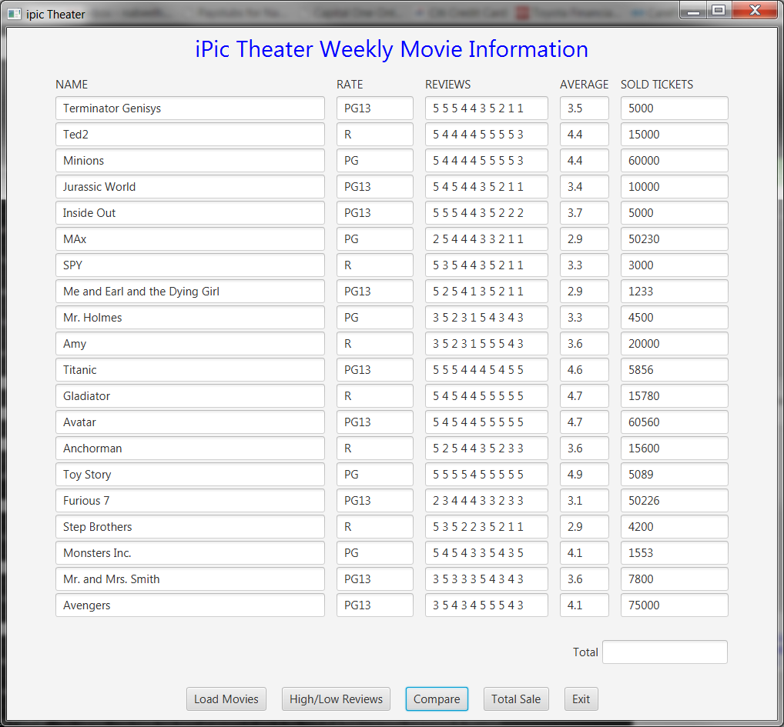

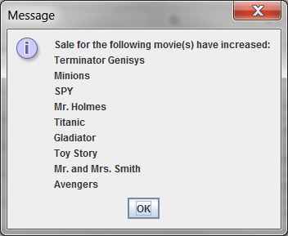

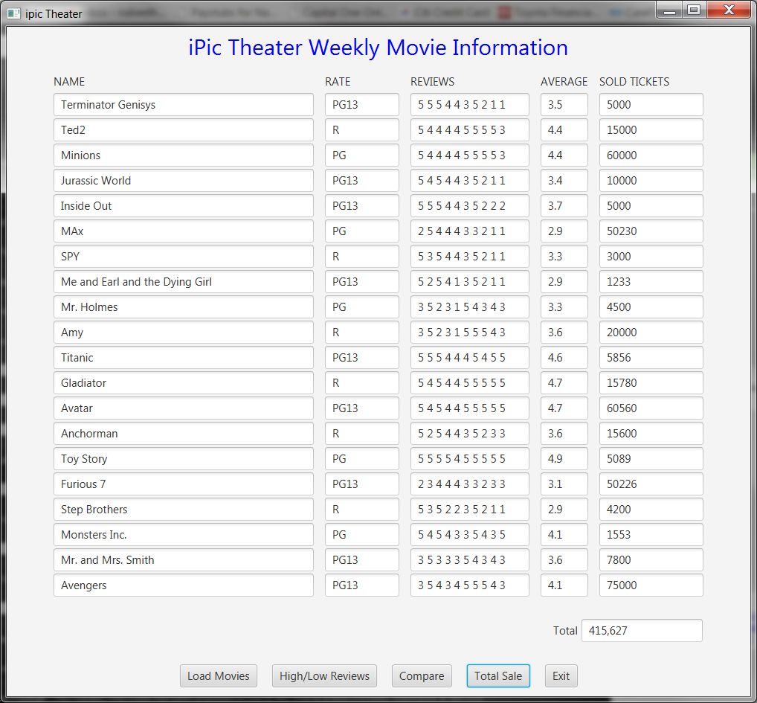

**Test file 2 - currWeekSale.txt**

**Test file 2 – prevWeekSale.txt**

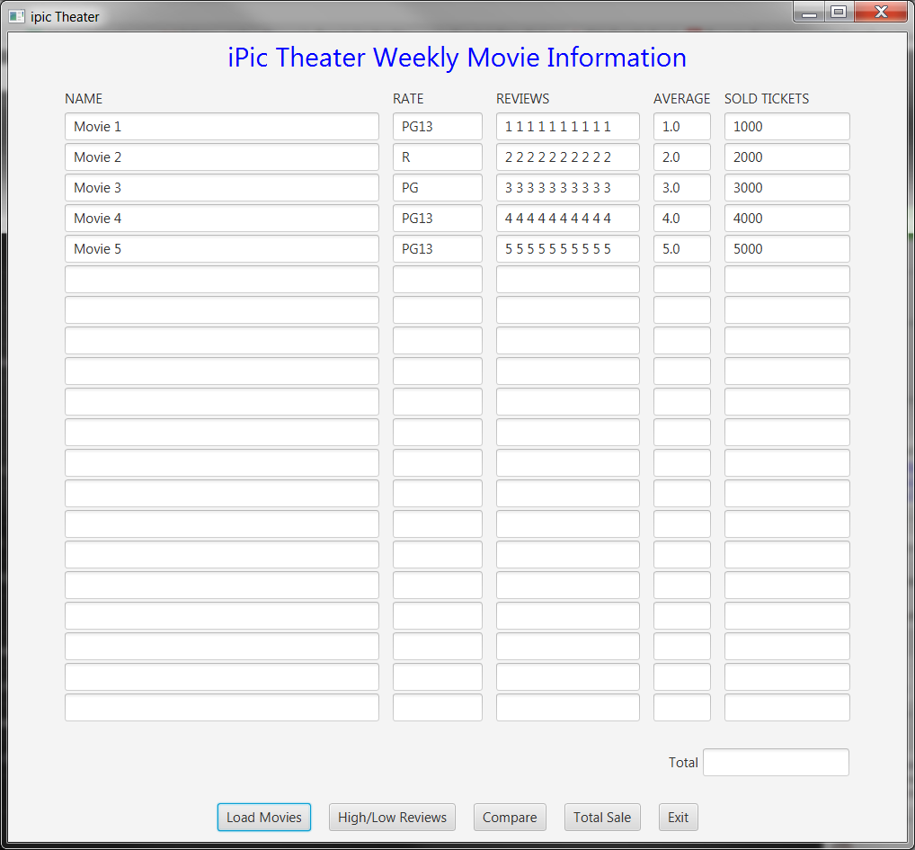

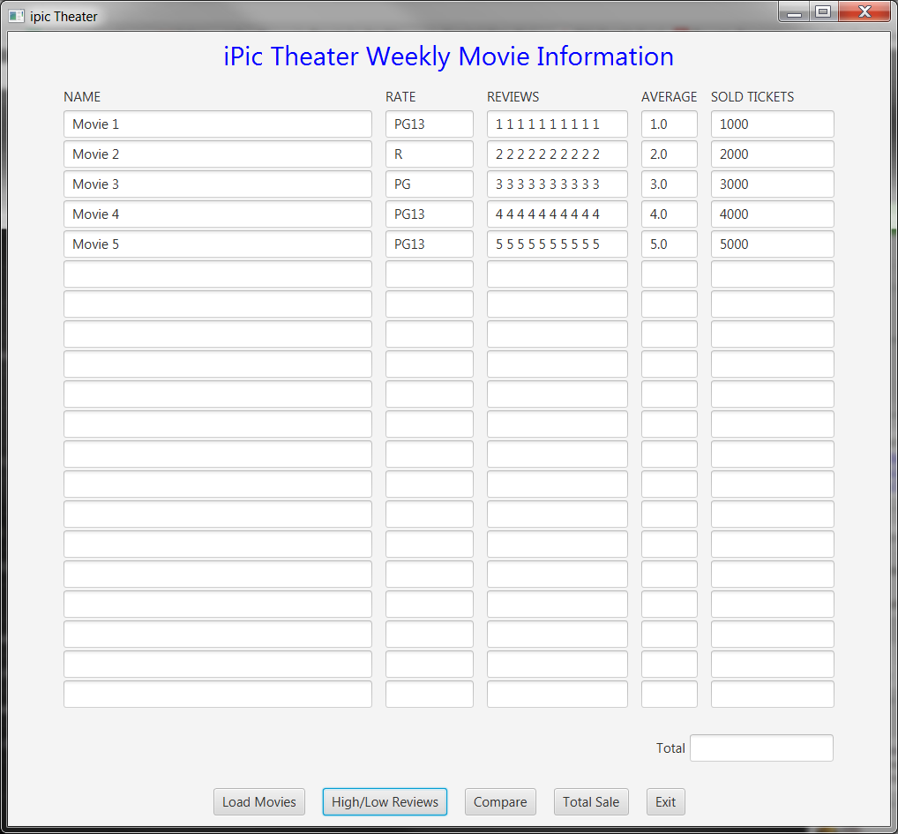



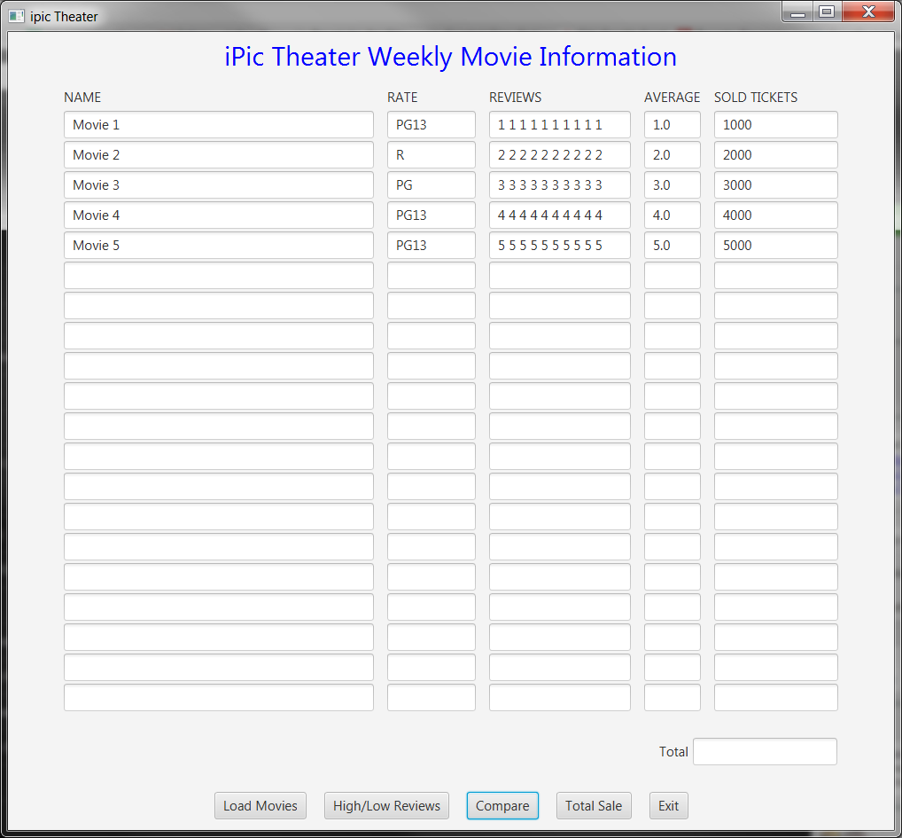

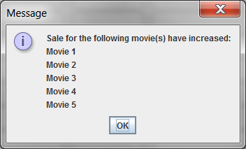

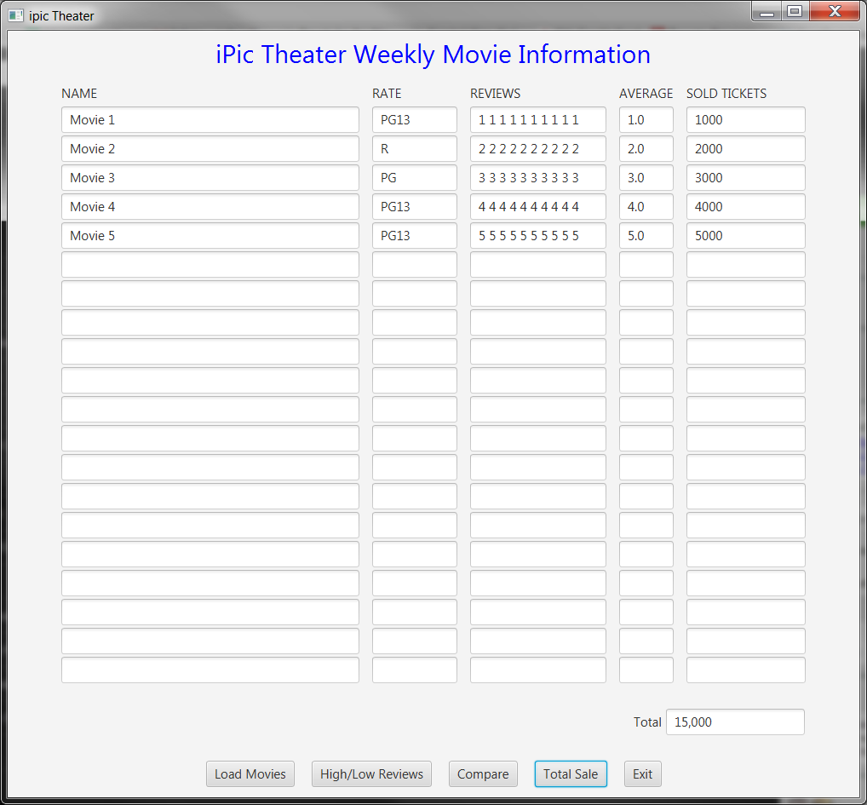

**Test file 3 - currWeekSale.txt**

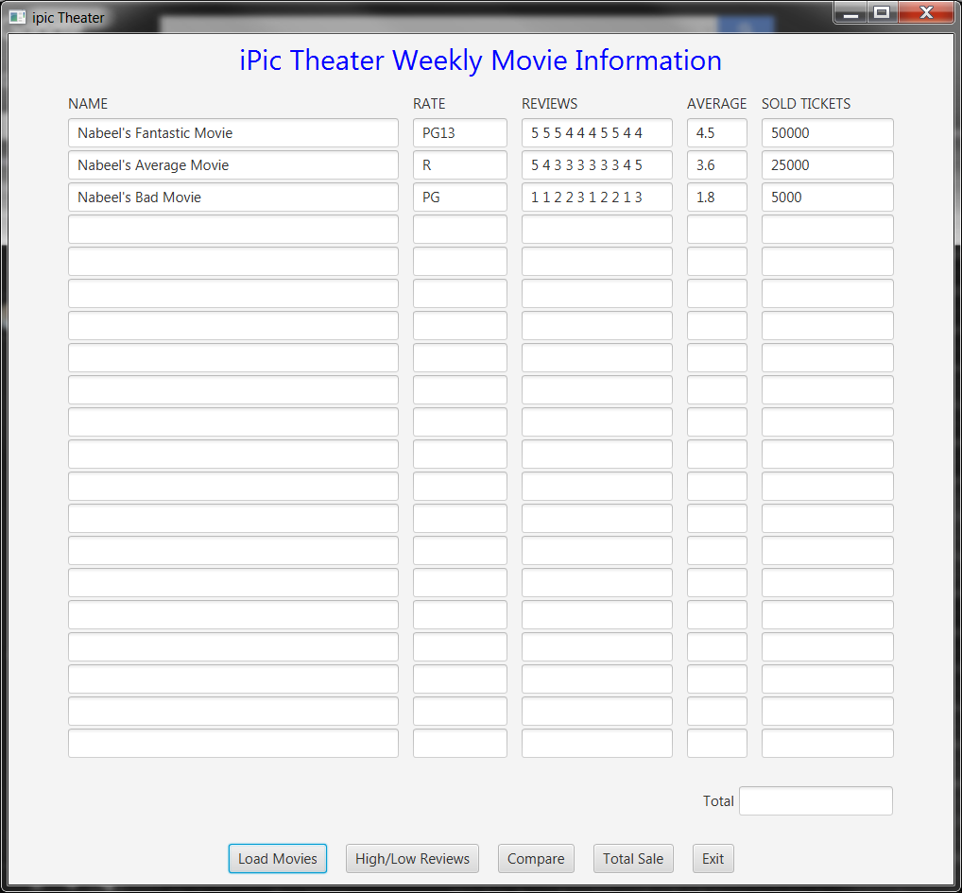**Test file 3 – prevWeekSale.txt**

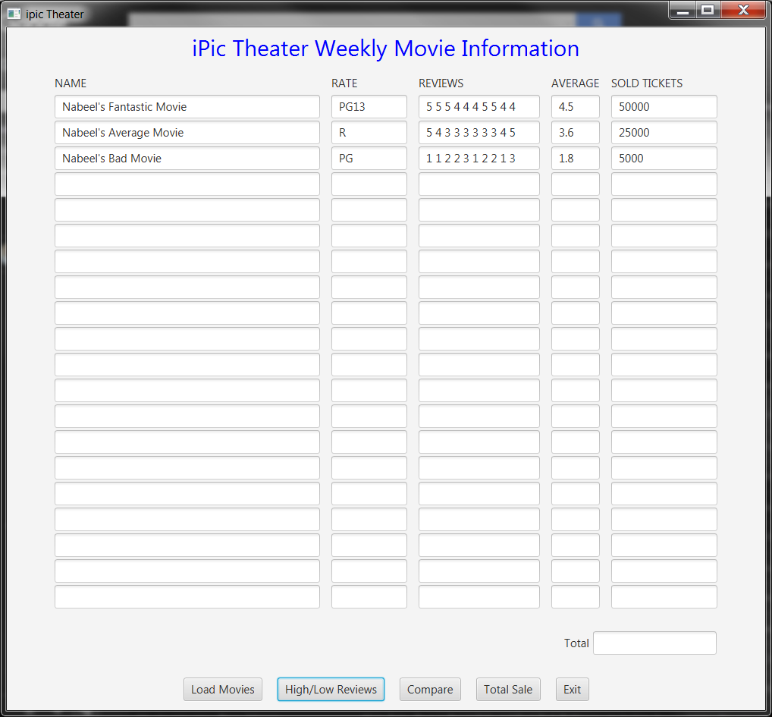



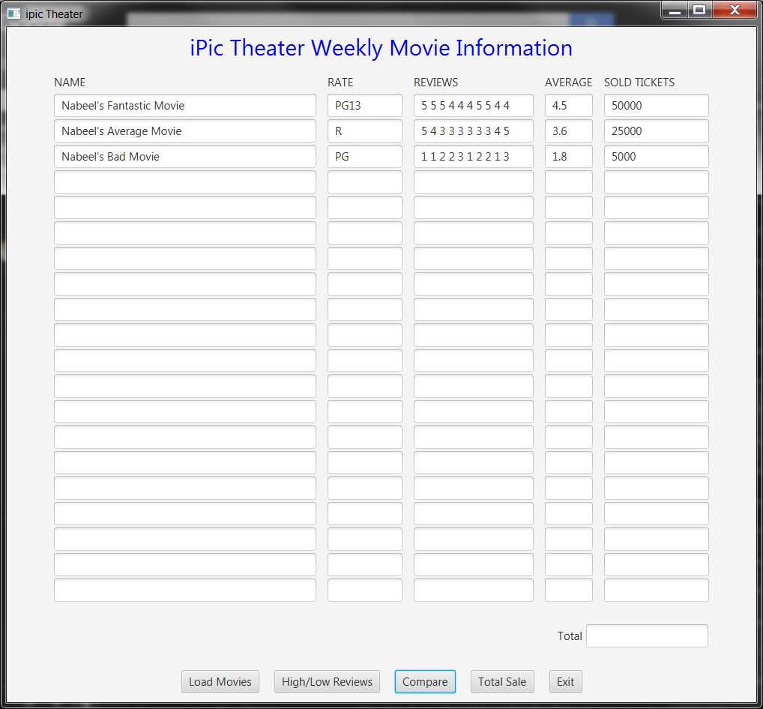

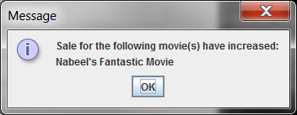

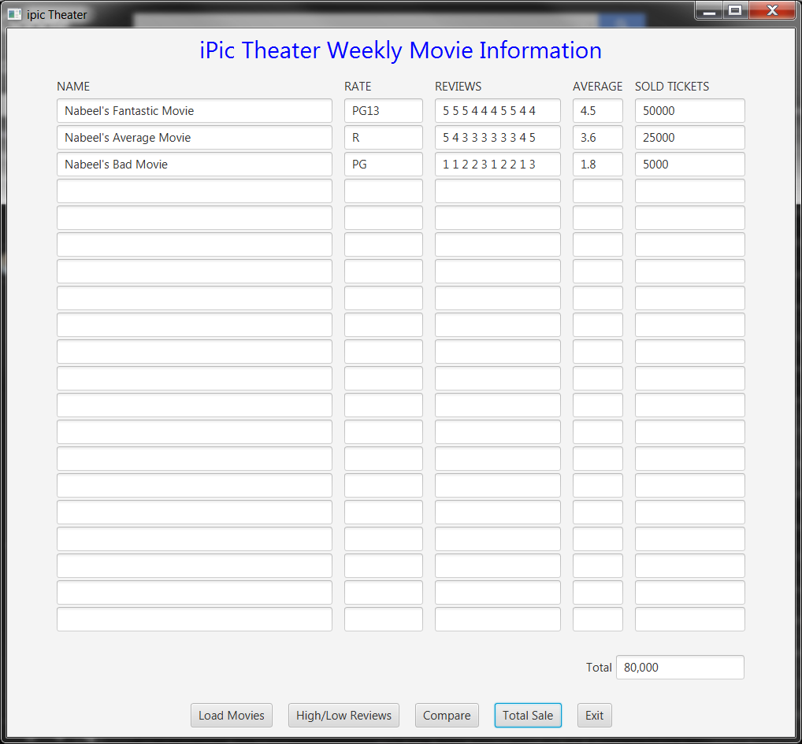

**You have been asked to use an ArrayList for holding Movie information in DataManager(MovieTheater ) class. Can you use a regular array instead? What are the Pros and Cons of using ArrayList over an Array? How would you change your interface to benefit from ArrayList structure?**

In my opinion it would not be possible to use a regular array for the DataManger class. This is because, in a regular array you need to know and initialize the size of an array ahead of time, before you are able to add information into it. In the Movie Theater application, we will not always know the exact number of movies that are going be in the database list, and as a result, we would not be able to set a regular arrays size.

An ArrayList is very similar to an array, however with some differences. Some advantages of using an ArrayList over an array are in its ability to expand as items are added to it. An ArrayList does not need to have a size set ahead of time, and can keep adding items one after another and expand. You can also remove items from an ArrayList as well and the size of the ArrayList shrinks as the items are removed. A regular array does not have this ability, and as a result, it is not useful to use when you need to add items of an unknown size. However, in instances where you have a predefined amount of items that will always be there, such as number of months in a year, hours in a day, etc… it might be best to use a regular array to store this type of information over an ArrayList.

How I would change the interface to benefit from an ArrayList structure is by storing the text fields in the application in an ArrayList, instead of assigning a preset number of rows to a regular array. As a result, the rows in the table will always match the number of movies that are in the database being imported. This will eliminate any unused rows being shown. For this assignment, I set the size of the array holding the textfields to 20, so if a database containing more than 20 movies were to be imported, then the application would not work properly.